**ESP8266 DEVICES TROUBLESHOOTING PROCESS**

We were unable to add the device to cloud and it keeps giving us unauthorized error. We were able to log in and generate JWT token but was unable to do any other thing .

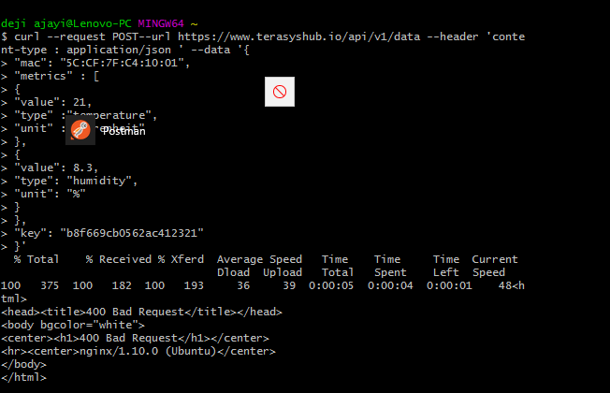

We added the key that Titus generated but it gave the error Bad request.

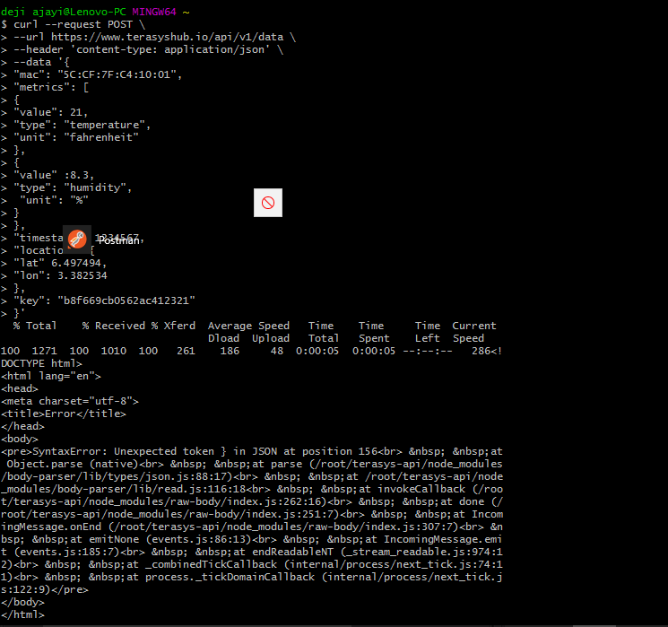

The error after we got when trying to send data to server using the key Titus sent to me.

After it gave the error above, we logged in, got an new JWt and tried regenerating new key for the device.

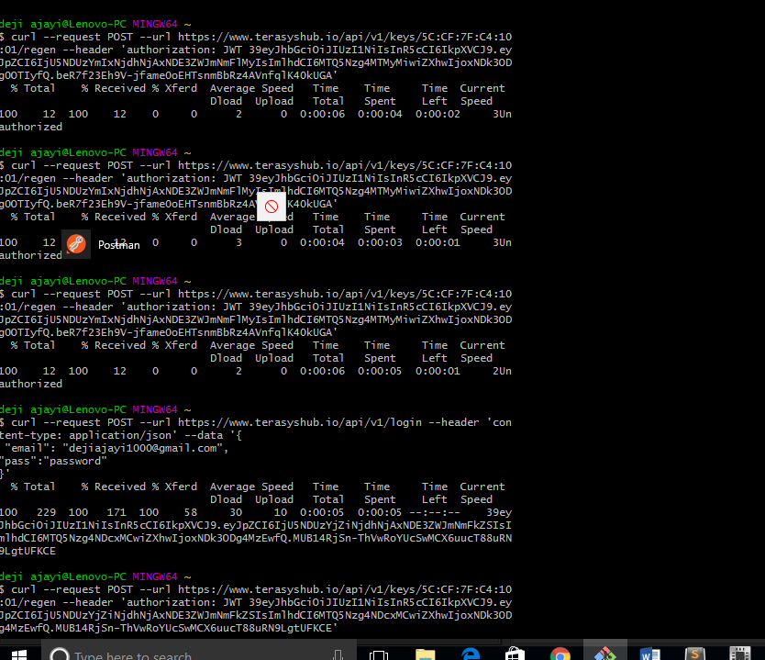

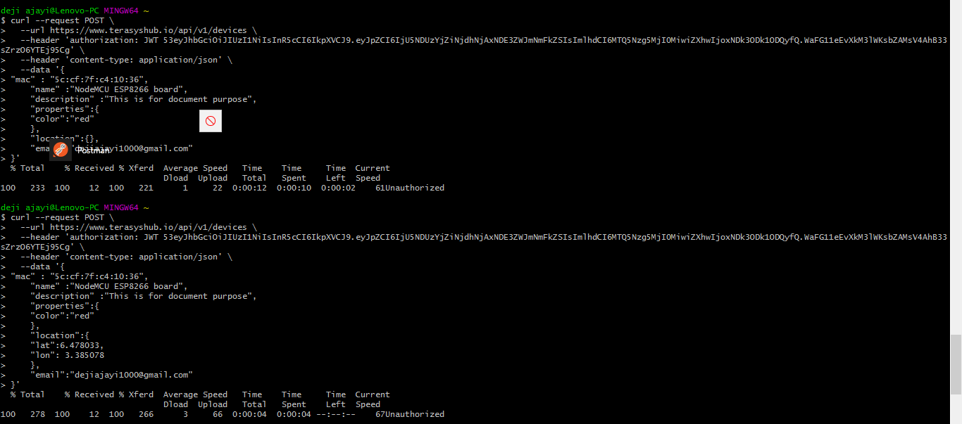

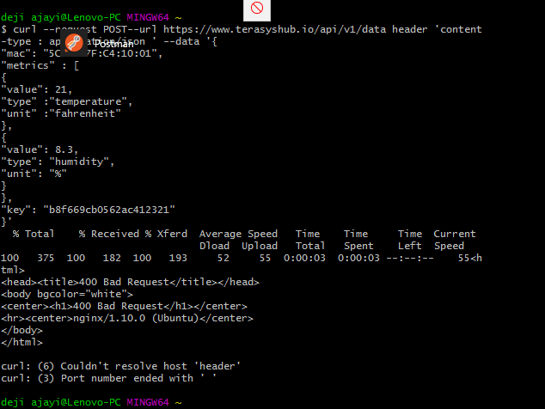

We contacted Titus and he gave us key and we tried sending data to cloud again.

After a lot of discussion with Titus we loaded the lua file on the esp8266 but got the error below.

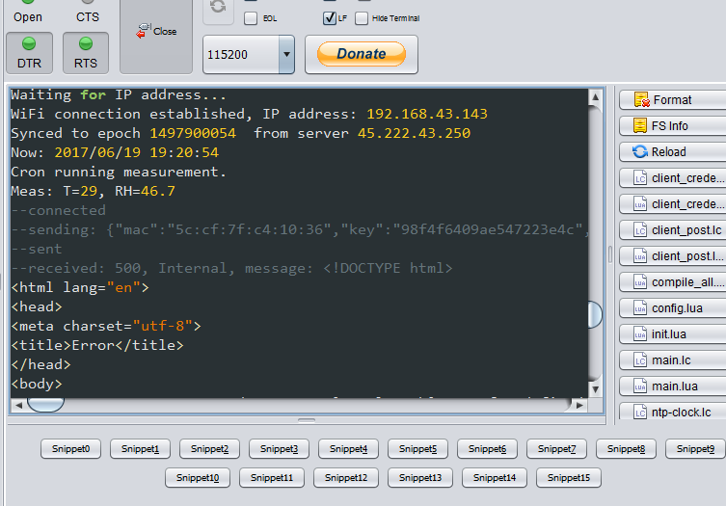

We therefore notice that the MAC address we got from flashing the devices is different from the mac address we got from the error message in the Esplorer GUI. We therefore added the mac address to cloud again and generated another key.

After that, I flashed the devices again and loaded the files on the devices.

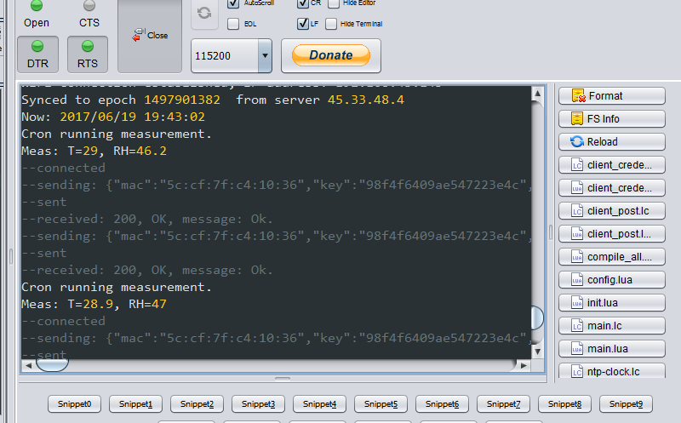

This screenshot above shows the devices is now working.

**CHALLENGES**

* Power supply. We had serious issue with this because the power supply in the office is terrible.
* Poor internet access. Most of the ISP are not working in the office so I had to do a new subscription on my MTN sim. Presently, MTN is the only network we can say is manageable in the office. Even spectranet is terrible. It affected us to the extent that most apps that we need to install took hours to download.
* Very slow PC. The pc is very slow coupled with bad network, it really affected our work. What we could have done in few minutes took us hours to do.